**Steps to Set Up an AWS EMR Cluster**

EMR Cluster can be setup from AWS Console, SDK or AWS CLI. For the blog we will cover setup via [**AWS Console**](https://aws.amazon.com/console/)**.**

**Step 1: Log in to AWS Console**

1. Login to [AWS Console](https://aws.amazon.com/console/).
2. Once logged in, search for “EMR” in the search bar and navigate to **Amazon EMR**.

**Step 2: Create EMR Cluster.**

1. In the EMR Cluster, click on “Create Cluster”

**Step 3: Configure the Software and Applications:**

1. Choose the EMR Release version: We are going to choose **emr-7.8.0**

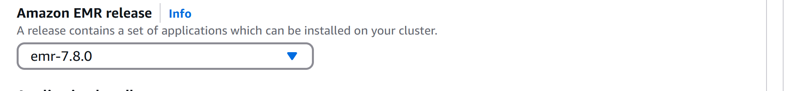

1. Choose the Application bundle: From the available choices we choose “Spark”. Checkmarks are chosen automatically based on the application choice you make.

**Step 4: Configure Instance Types and Cluster Size :**

Choose a configuration method for the primary, core, and task node groups for your cluster.

Chose the Primary or Master Node:

1. **Choose EC2 Instance Types**:
   1. Master Node: Choose an instance type like m5-xlarge
   2. Core Nodes : Something like r5.xlarge for memory intensive applications like Spark.
   3. Task Nodes : If your workload needs extra processing power without additional storage , make use of Task node for optimizing Cluster performance.
2. Cluster Sizing: For optimal performance and cost-effectiveness, tailor your cluster size to your specific needs. Define the initial number of instances for each node type, considering both your data volume and processing intensity. EMR's built-in auto-scaling functionality provides the flexibility to automatically scale the cluster up or down based on real-time workload fluctuations, preventing unnecessary resource overhead.

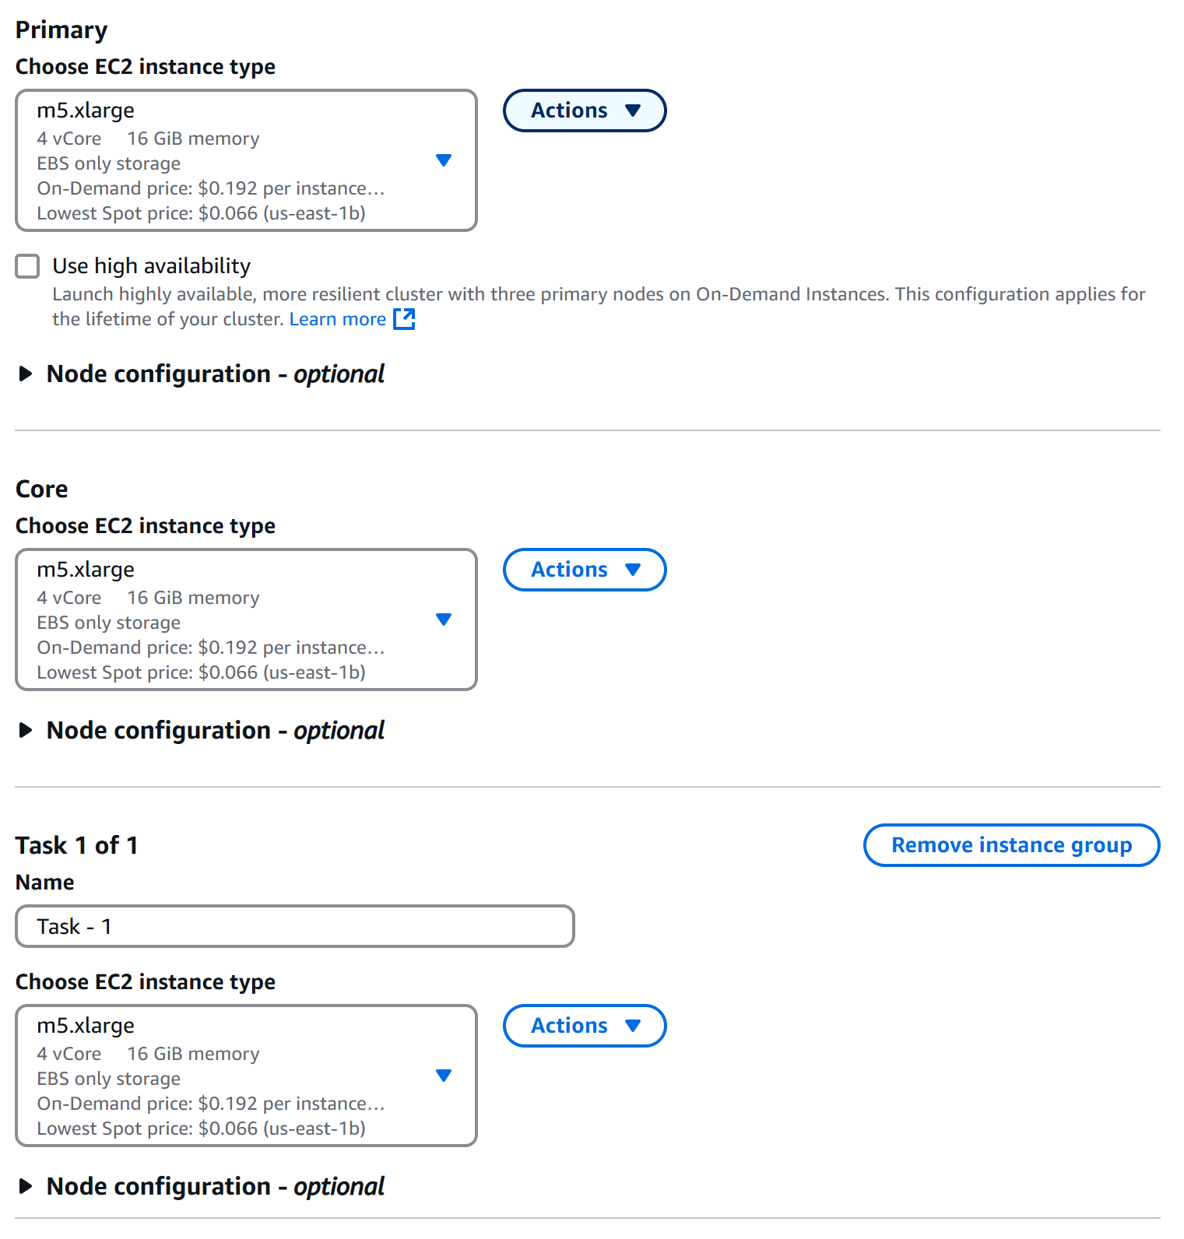

**Step 5: Enabling EMR-Managed Scaling for Auto-Scaling**

Chosen below is the “Use EMR-managed scaling” , since we want EMR to dynamically auto scale based on workload. Here you can also specify the Min and Max Cluster Size and also choose Max Core Nodes and On-Demand instances in cluster.

You can also specify number of instance that the cluster starts with under the “Provisioning Configuration” setting.

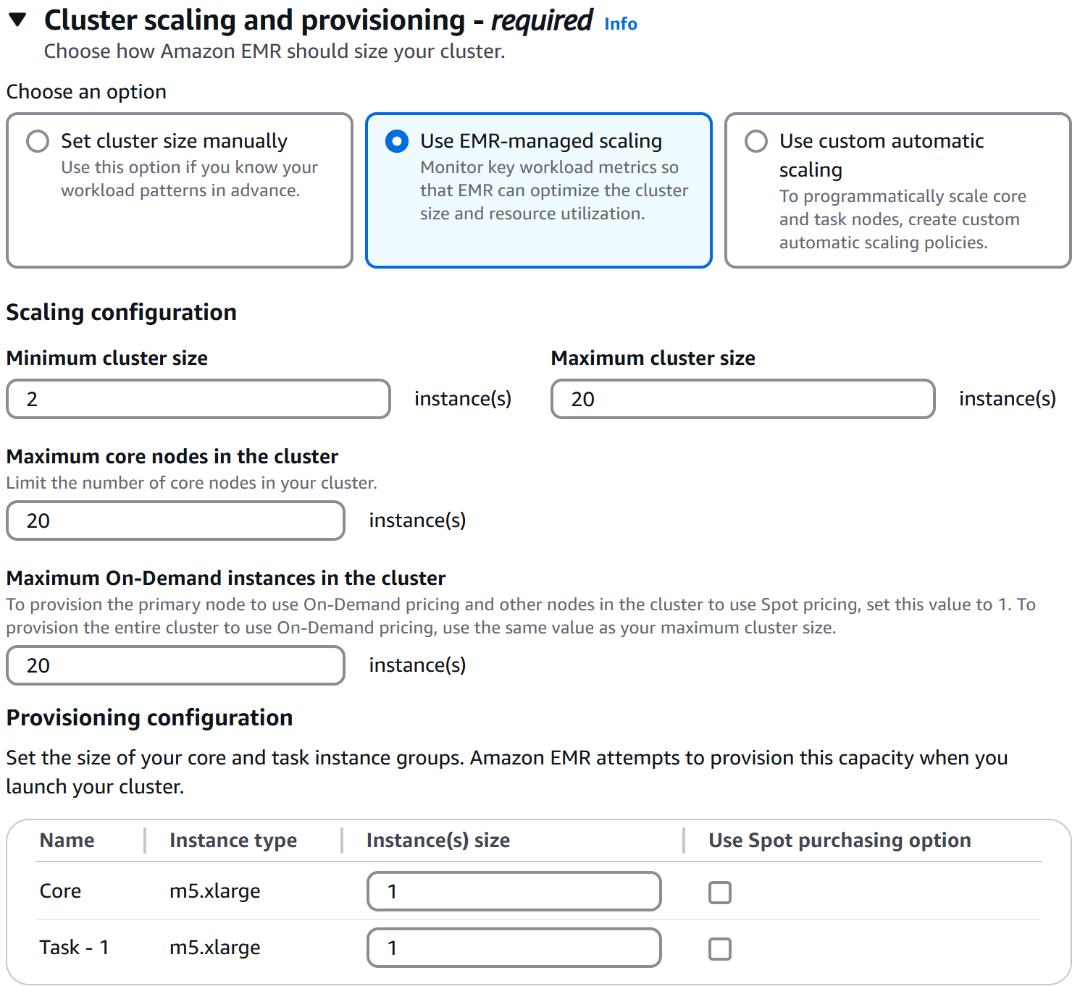

**Step 6: Networking and Security Configuration**

* 1. **VPN and Network Configuration:** Choose the appropriate VPC and Firewall for your EMR Setup.
  2. **IAM Role configuration :**

Choose or create new IAM Role granting necessary permissions to the clusters to interact with other AWS services like S3, Dynamo DB etc.

* 1. EMR Default Role: Allows cluster to interact with S3 and Dynamobo DB and other services.
  2. EMR Default EC2 Role : Grants EC2 instances in the cluster necessary permission

In our case we choose Amazon to create the Service Roles and Atoscaling Role for EC2. Please see our preferences below.

**Step 7 : Logs:**

Configure AWS S3 location for logging.

**Step 8: Review and Create Cluster:**

* 1. Review all configuration.
  2. After a through review hit the “Create Cluster”

**Step 9: Manage and Monitor the Cluster.**

1. Once your cluster is up and running, you can monitor its status via the **EMR Dashboard**.
2. Use **AWS CloudWatch** for real-time monitoring of cluster metrics, resource utilization, and job progress.
3. You can also SSH into the master node if you need to directly manage or troubleshoot the cluster.